**Индивидуальное задание 5:**

**проектирование и разработка БД**

**Разработать приложение, которое будет включать следующие функции:**

* Просмотр любых таблиц баз данных СУБД MS SQL(Кроме служебных)
* Базы данных и таблицы пользователь выбирает из выпадающего списка

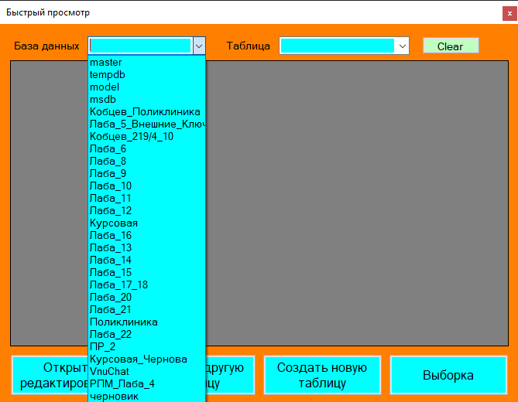

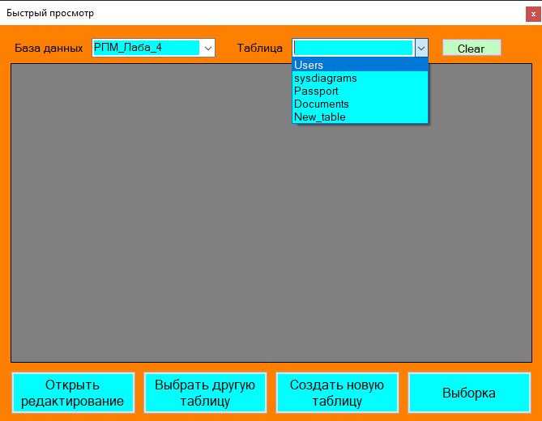

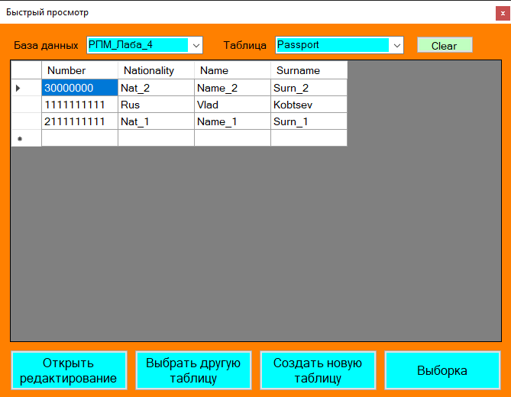

* 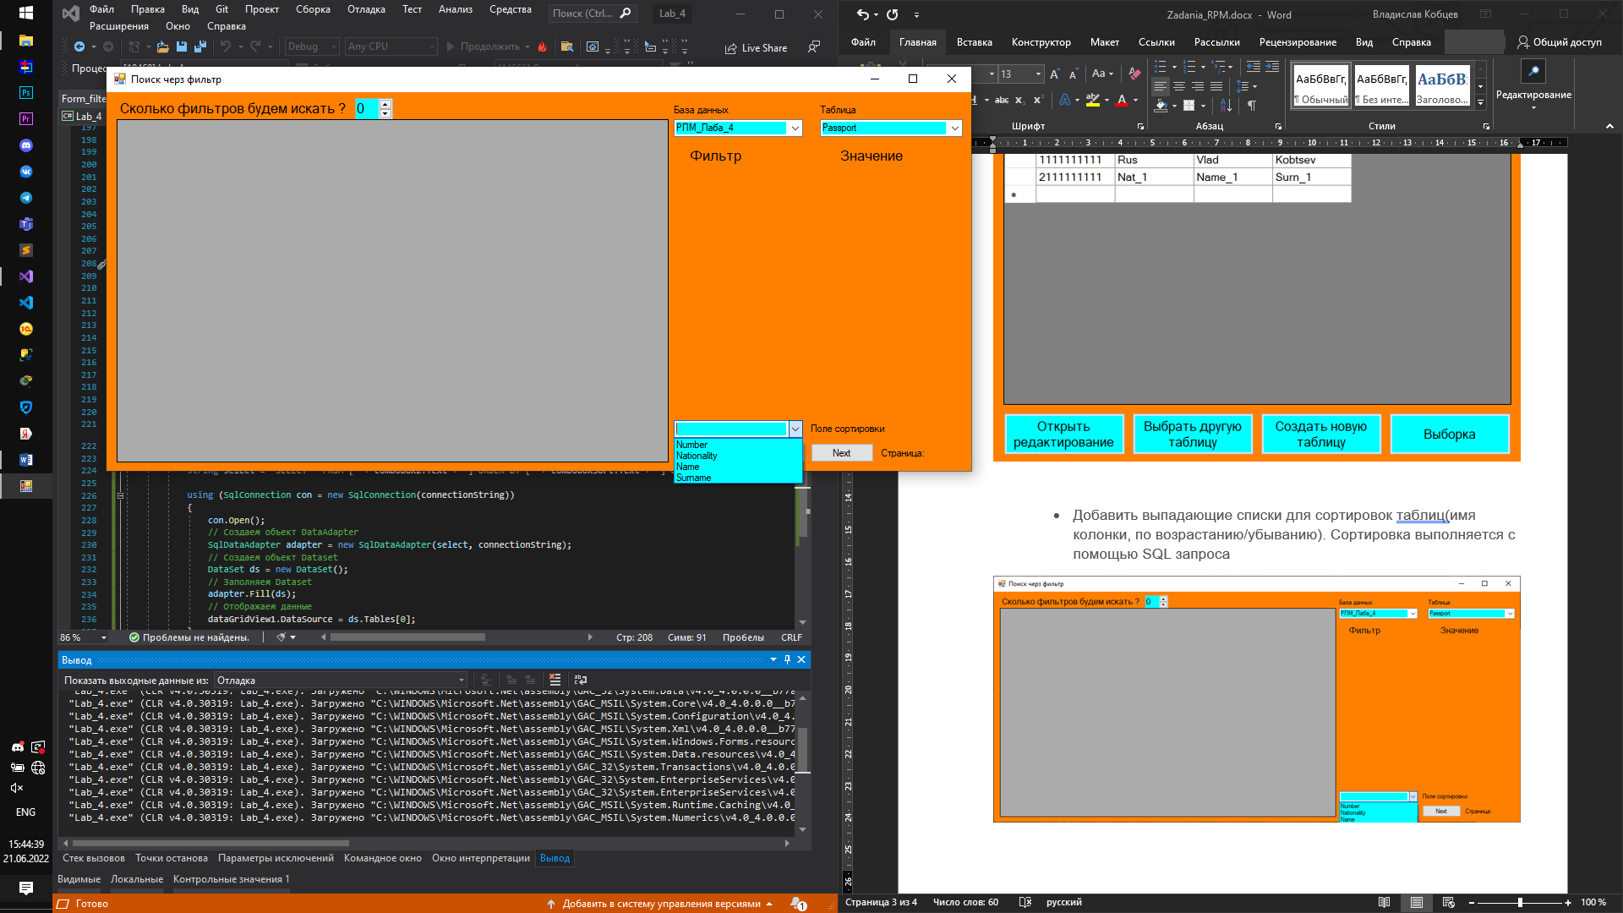Добавить выпадающие списки для сортировок таблиц(имя колонки, по возрастанию/убыванию). Сортировка выполняется с помощью SQL запроса

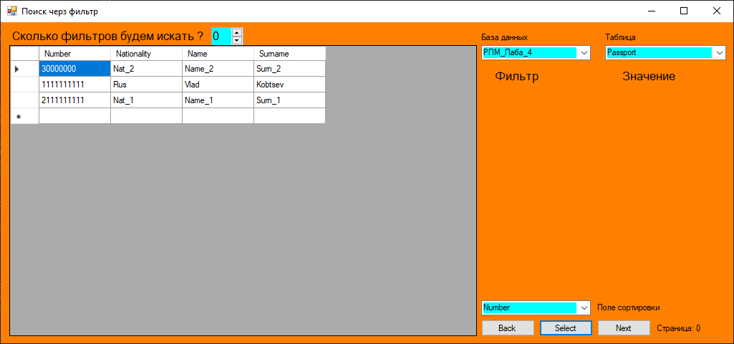

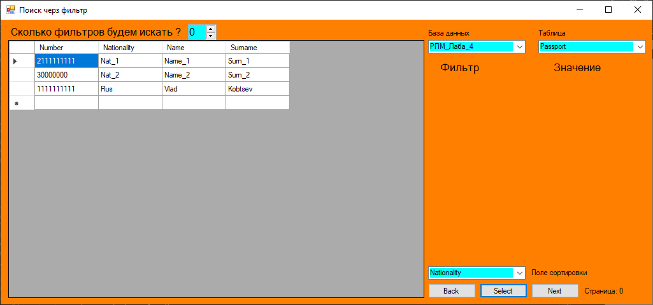

* Постраничный просмотр данных

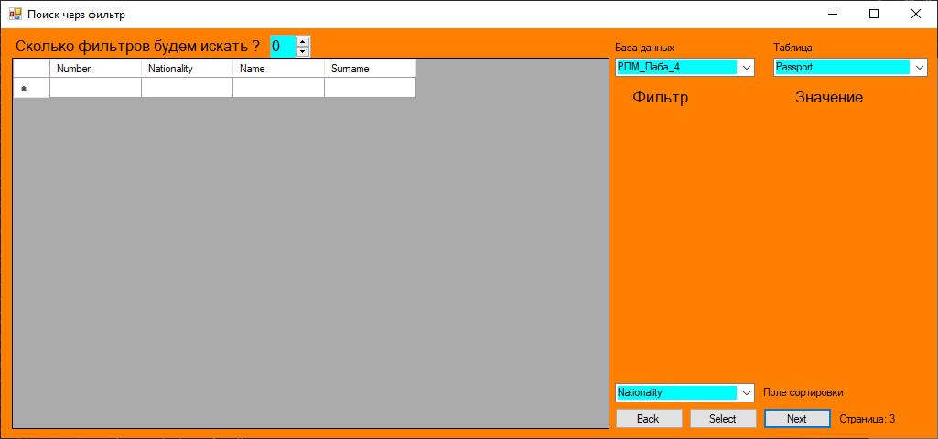

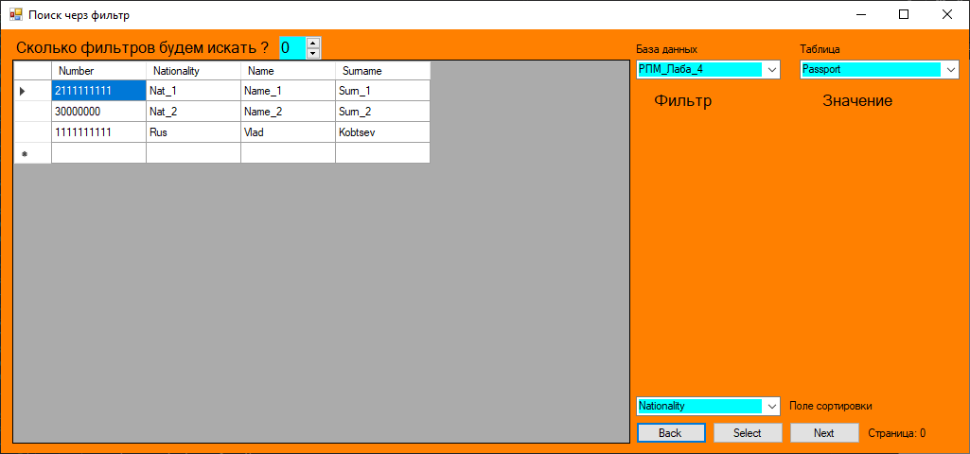

**Код главной формы**

using System;

using System.Collections.Generic;

using System.Data;

using System.Data.SqlClient;

using System.Windows.Forms;

namespace Lab_4

{

public partial class Form_main : Form

{

public SqlConnection connection;

public Form_main()

{

InitializeComponent();

connection = new SqlConnection(connectionString);

}

List<ComboBox> listCb = new List<ComboBox>();

List<TextBox> listTb = new List<TextBox>();

string db_name;

string table_name;

string connectionString = @"Data Source = DriveFallen\SQLEXPRESS ;Initial Catalog = РПМ_Лаба_4 ;Integrated Security=True";

private void Form_main_Load(object sender, EventArgs e)

{

string sel = "SELECT name FROM sys.databases";

SqlCommand select_all_DB = new SqlCommand(sel, connection);

connection.Open();

SqlDataReader dataReader = select_all_DB.ExecuteReader();

while(dataReader.Read())

{

comboBox1.Items.Add(dataReader.GetString(0));

}

connection.Close();

}

private void button_redactor_Click(object sender, EventArgs e)

{

this.Hide();

Form_redactor form4 = new Form_redactor();

form4.Show();

}

private void button_open_Click(object sender, EventArgs e)

{

using(Choose_table choose_Table = new Choose_table())

{

DialogResult dialogResult = choose_Table.ShowDialog();

db_name = (dialogResult == DialogResult.OK) ? choose_Table.ComboResultDB : string.Empty;

table_name = (dialogResult == DialogResult.OK) ? choose_Table.ComboResultTable : string.Empty;

}

if (table_name != string.Empty)

{

string select_table = "USE " + db_name + " SELECT * FROM [" + table_name + "]";

using (SqlConnection con = new SqlConnection(connectionString))

{

con.Open();

// Создаем объект DataAdapter

SqlDataAdapter adapter = new SqlDataAdapter(select_table, connectionString);

// Создаем объект Dataset

DataSet ds = new DataSet();

// Заполняем Dataset

adapter.Fill(ds);

// Отображаем данные

dataGridView1.DataSource = ds.Tables[0];

}

MessageBox.Show(string.Format("Вы выбрали таблицу: {0}", table_name), "Другая таблица выбрана!", MessageBoxButtons.OK, MessageBoxIcon.Information);

}

}

private void button_create_Click(object sender, EventArgs e)

{

this.Hide();

Form_second form_sec = new Form_second();

form_sec.ShowDialog();

}

private void button_filter_Click(object sender, EventArgs e)

{

this.Hide();

Form_filter form_main = new Form_filter();

form_main.Show();

}

private void comboBox1_SelectedIndexChanged(object sender, EventArgs e)

{

comboBox2.Items.Clear();

string sel = "USE " + comboBox1.Text + " SELECT * FROM sys.tables";

SqlCommand select_all_DB = new SqlCommand(sel, connection);

connection.Open();

SqlDataReader dataReader = select_all_DB.ExecuteReader();

while (dataReader.Read())

{

comboBox2.Items.Add(dataReader.GetString(0));

}

connection.Close();

}

private void comboBox2_SelectedIndexChanged(object sender, EventArgs e)

{

string select_table = "USE " + comboBox1.Text + " SELECT * FROM [" + comboBox2.Text + "]";

using (SqlConnection con = new SqlConnection(connectionString))

{

con.Open();

SqlDataAdapter adapter = new SqlDataAdapter(select_table, connectionString);

DataSet ds = new DataSet();

adapter.Fill(ds);

dataGridView1.DataSource = ds.Tables[0];

}

}

private void buttonClear_Click(object sender, EventArgs e)

{

comboBox1.Text = string.Empty;

comboBox2.Text = string.Empty;

comboBox2.Items.Clear();

dataGridView1.Columns.Clear();

}

}

}

**Код формы фильтр**

using System;

using System.Collections.Generic;

using System.Data;

using System.Data.SqlClient;

using System.Drawing;

using System.Windows.Forms;

namespace Lab_4

{

public partial class Form_filter : Form

{

SqlConnection connection;

public Form_filter()

{

InitializeComponent();

connection = new SqlConnection(connectionString);

}

List<ComboBox> listCb = new List<ComboBox>();

List<TextBox> listTb = new List<TextBox>();

public List<string> listColName = new List<string>();

string connectionString = @"Data Source = DriveFallen\SQLEXPRESS ;Initial Catalog = РПМ_Лаба_4 ;Integrated Security=True";

private void Form3_Load(object sender, EventArgs e)

{

string sel = "SELECT name FROM sys.databases";

SqlCommand select_all_DB = new SqlCommand(sel, connection);

connection.Open();

SqlDataReader dataReader = select_all_DB.ExecuteReader();

while (dataReader.Read())

{

comboBox1.Items.Add(dataReader.GetString(0));

}

connection.Close();

flowLayoutPanel1.Controls.Clear();

}

private void Form3_FormClosing(object sender, FormClosingEventArgs e)

{

Form_main form_main = new Form_main();

form_main.Show();

}

private void numericUpDown1_ValueChanged(object sender, EventArgs e)

{

listCb.Clear();

listTb.Clear();

flowLayoutPanel1.Controls.Clear();

int value = (int)numericUpDown1.Value;

for (int i = 0; i < value; i++)

{

ComboBox comboBox = new ComboBox()

{

Width = 160, Height = 24,

};

TextBox textBox = new TextBox()

{

Width = 156, Height = 24,

};

flowLayoutPanel1.Controls.Add(comboBox);

listCb.Add(comboBox);

for (int k = 0; k < listColName.Count; k++)

{

comboBox.Items.Add(listColName[k]);

}

flowLayoutPanel1.Controls.Add(textBox);

listTb.Add(textBox);

}

Button button = new Button()

{

Width = 100, Height = 30,

Text = "Выбрать",

};

flowLayoutPanel1.Controls.Add(button);

button.Click += button1_Click;

}

private void button1_Click(object sender, EventArgs e)

{

string select_table = "SELECT ";

for (int i=0; i < listCb.Count; i++)

{

select_table += listCb[i].Text + ", ";

}

select_table = select_table.Substring(0,select_table.Length - 2) + " FROM " + comboBox2.Text;

string count ="";

for (int i = 0; i < listTb.Count;i++)

{

count += listTb[i].Text;

}

if(count != string.Empty)

{

select_table += " where ";

string where_str = "";

for (int i = 0; i < listTb.Count; i++)

{

if (listTb[i].Text != string.Empty)

{

where_str += listCb[i].Text + " = " + listTb[i].Text + " and ";

}

}

select_table += where_str.Substring(0, where_str.Length - 5);

}

Console.WriteLine(select_table);

using (SqlConnection con = new SqlConnection(connectionString))

{

con.Open();

// Создаем объект DataAdapter

SqlDataAdapter adapter = new SqlDataAdapter(select_table, connectionString);

// Создаем объект Dataset

DataSet ds = new DataSet();

// Заполняем Dataset

adapter.Fill(ds);

// Отображаем данные

dataGridView1.DataSource = ds.Tables[0];

}

}

private void comboBox1_SelectedIndexChanged(object sender, EventArgs e)

{

comboBoxSort.Items.Clear();

comboBox2.Items.Clear();

string sel = "USE " + comboBox1.Text + " SELECT * FROM sys.tables";

SqlCommand select_all_DB = new SqlCommand(sel, connection);

connection.Open();

SqlDataReader dataReader = select_all_DB.ExecuteReader();

while (dataReader.Read())

{

comboBox2.Items.Add(dataReader.GetString(0));

}

connection.Close();

}

private void comboBox2_SelectedIndexChanged(object sender, EventArgs e)

{

listColName.Clear();

comboBoxSort.Items.Clear();

string select = "SELECT COLUMN_NAME FROM ["+ comboBox1.Text + "].INFORMATION_SCHEMA.COLUMNS WHERE[TABLE_NAME] = '" + comboBox2.Text + "'";

using (SqlConnection con = new SqlConnection(connectionString))

{

SqlCommand select_table = new SqlCommand(select, con);

con.Open();

SqlDataReader dataReader = select_table.ExecuteReader();

int i = 0;

while (dataReader.Read())

{

listColName.Add(dataReader.GetString(0));

comboBoxSort.Items.Add(listColName[i]);

i++;

}

}

}

int positionNow = 0;

private void buttonSelect_Click(object sender, EventArgs e)

{

string select = "SELECT * FROM [" + comboBox2.Text + "] ORDER BY [" + comboBoxSort.Text + "] OFFSET " + positionNow.ToString() + " ROWS FETCH NEXT 3 ROWS ONLY";

Console.WriteLine(select);

using (SqlConnection con = new SqlConnection(connectionString))

{

con.Open();

// Создаем объект DataAdapter

SqlDataAdapter adapter = new SqlDataAdapter(select, connectionString);

// Создаем объект Dataset

DataSet ds = new DataSet();

// Заполняем Dataset

adapter.Fill(ds);

// Отображаем данные

dataGridView1.DataSource = ds.Tables[0];

}

labelStr.Text = "Страница: " + positionNow.ToString();

}

private void buttonBack_Click(object sender, EventArgs e)

{

if(positionNow != 0)

{

labelStr.Text = "Страница: " + positionNow.ToString();

string select = "SELECT * FROM [" + comboBox2.Text + "] ORDER BY [" + comboBoxSort.Text + "] OFFSET " + (positionNow - 3).ToString() + " ROWS FETCH NEXT 3 ROWS ONLY";

using (SqlConnection con = new SqlConnection(connectionString))

{

con.Open();

// Создаем объект DataAdapter

SqlDataAdapter adapter = new SqlDataAdapter(select, connectionString);

// Создаем объект Dataset

DataSet ds = new DataSet();

// Заполняем Dataset

adapter.Fill(ds);

// Отображаем данные

dataGridView1.DataSource = ds.Tables[0];

}

positionNow -= 3;

labelStr.Text = "Страница: " + positionNow.ToString();

}

}

private void buttonNext_Click(object sender, EventArgs e)

{

string select = "SELECT * FROM [" + comboBox2.Text + "] ORDER BY [" + comboBoxSort.Text + "] OFFSET " + (positionNow + 3).ToString() + " ROWS FETCH NEXT 3 ROWS ONLY";

using (SqlConnection con = new SqlConnection(connectionString))

{

con.Open();

// Создаем объект DataAdapter

SqlDataAdapter adapter = new SqlDataAdapter(select, connectionString);

// Создаем объект Dataset

DataSet ds = new DataSet();

// Заполняем Dataset

adapter.Fill(ds);

// Отображаем данные

dataGridView1.DataSource = ds.Tables[0];

}

positionNow += 3;

labelStr.Text = "Страница: " + positionNow.ToString();

}

}

}